- Typical Home Wi-Fi Setup

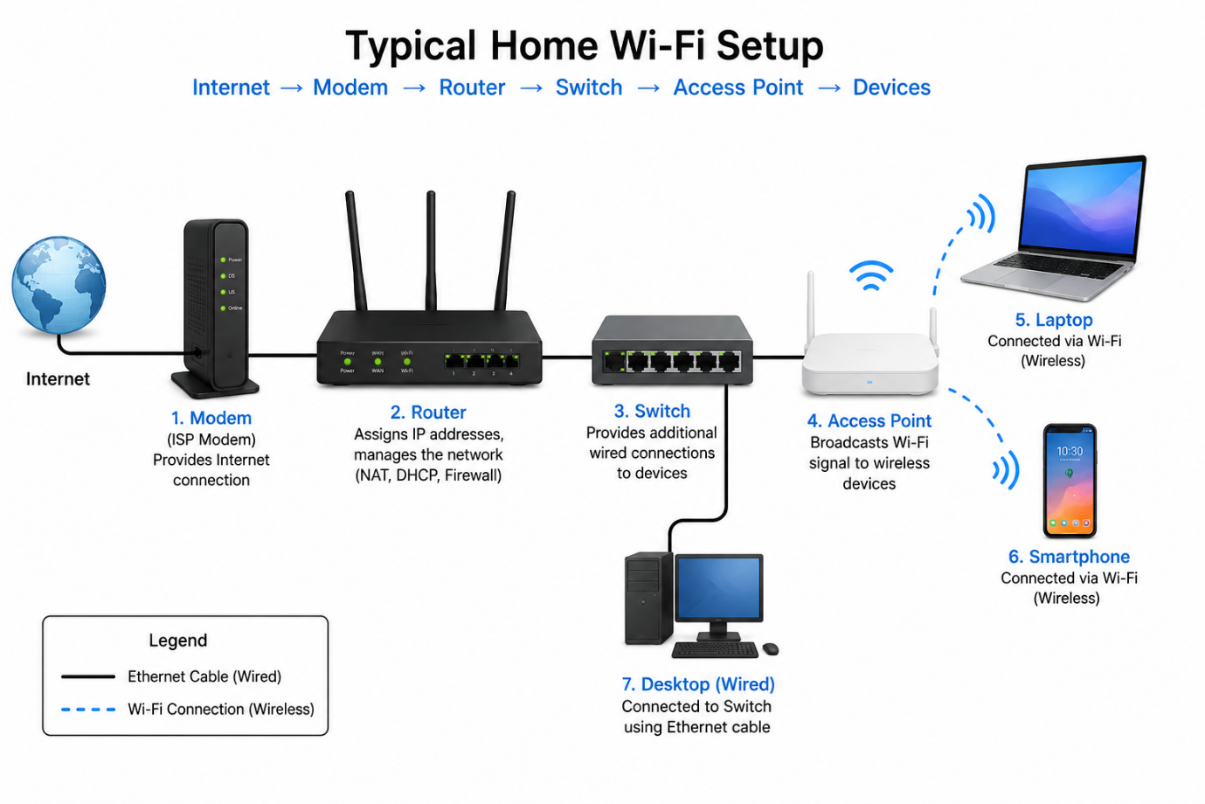

- Main Functions of Networking Hardware

Networking Hardware | Main Function | Real-Life Example
- Modem | Connects the home network to the Internet provided by the ISP. | At home, connected to the internet service.
- Router | Shares the Internet with multiple devices and manages the network. | At home to connect laptops and smartphones to Wi-Fi.
- Switch | Connects multiple wired devices in the same network. | In a school computer lab or office.
- Access Point (AP) | Provides or extends a Wi-Fi signal for wireless devices. | In a college, hotel, or large office to increase Wi-Fi coverage.
- Network Cable (Ethernet Cable) | Transfers data through a wired connection between network devices. | Connecting a PC to a router or switch.

- Types of Network Cables and Their Uses

- Ethernet Cable (RJ45)
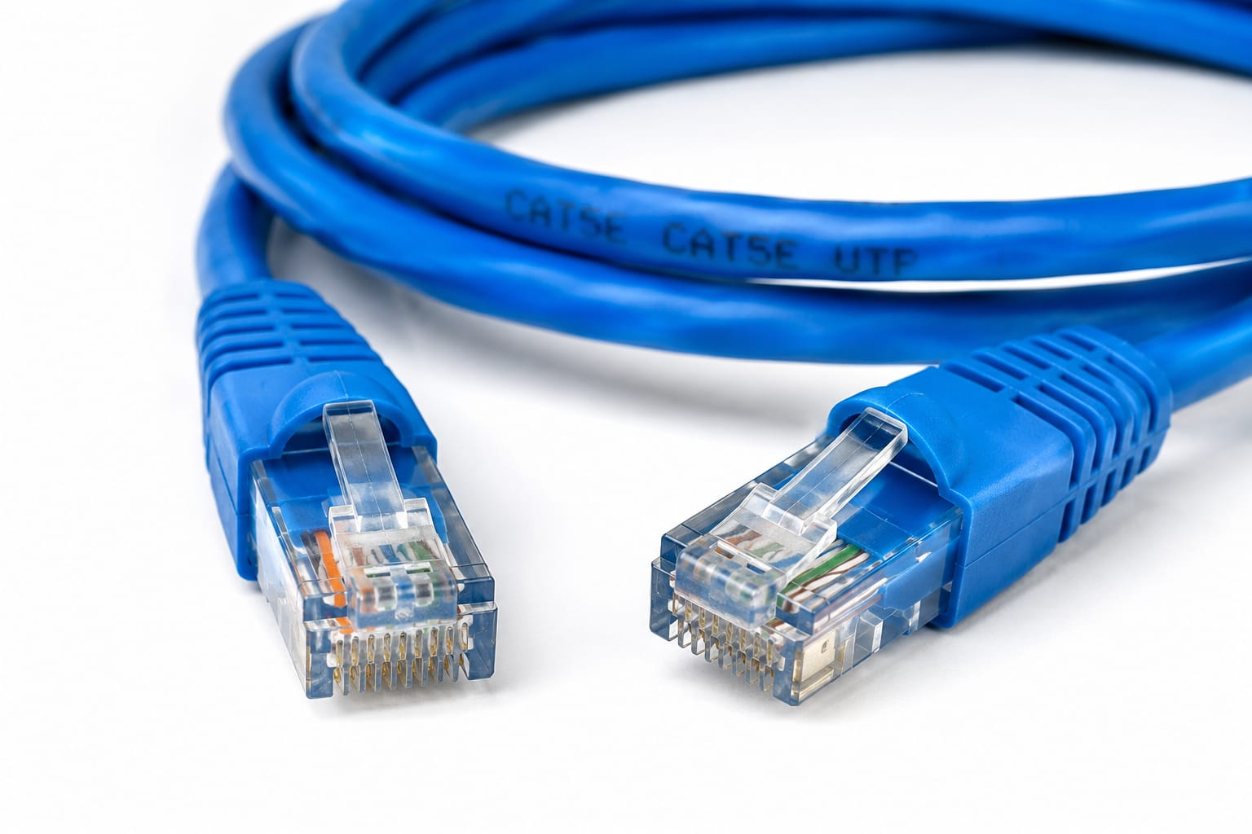

Common Use: Used to connect computers, routers, and switches in homes, schools, and offices.
Source: https://en.wikipedia.org/wiki/Ethernet_over_twisted_pair

- Coaxial Cable
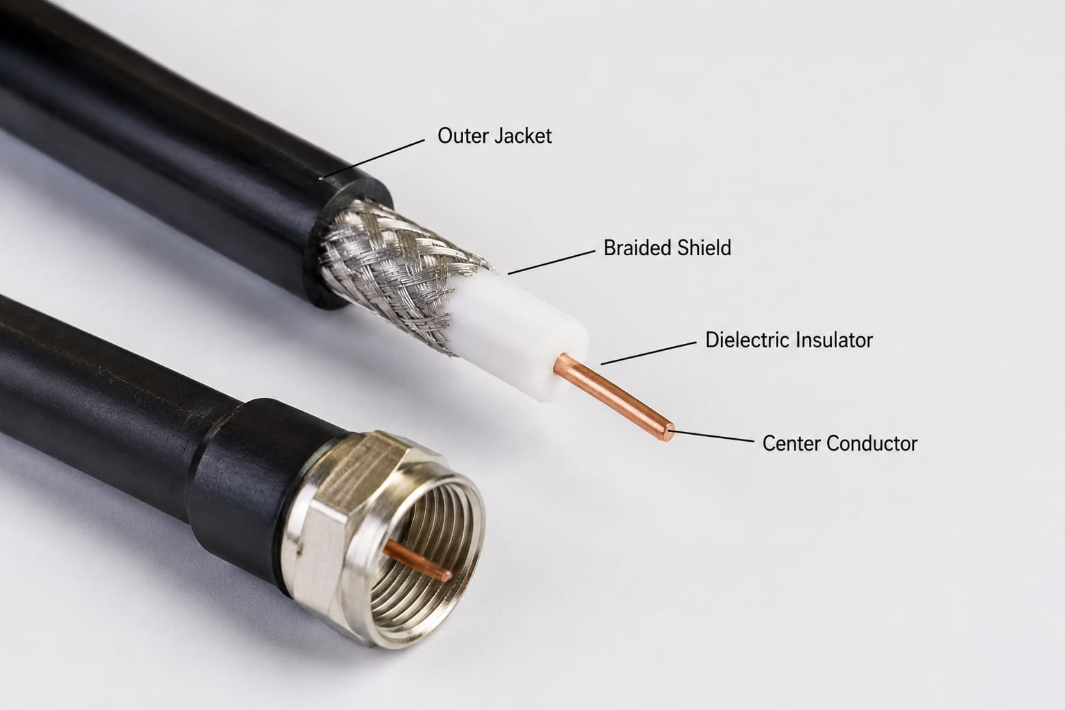
Common Use: Commonly used for cable TV connections, cable internet, and CCTV systems.
Source: https://en.wikipedia.org/wiki/Coaxial_cable

- Fiber Optic Cable
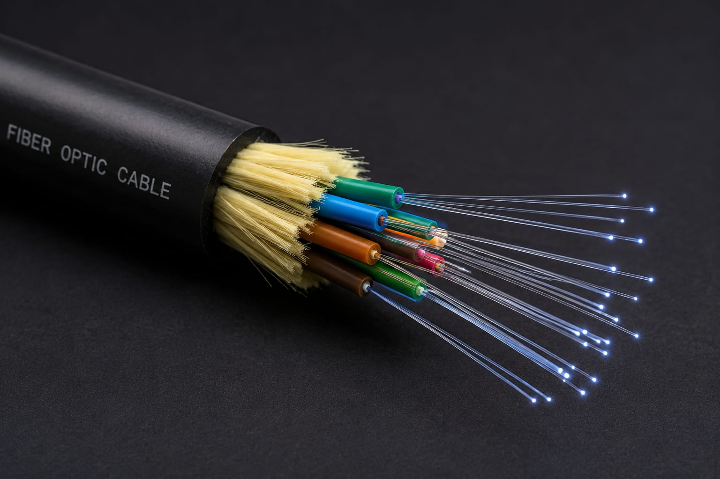

Common Use: Used for high-speed internet connections and long-distance communication.
Source: https://en.wikipedia.org/wiki/Optical_fiber

- Comparison Between Router and Switch⁠⁠

Feature | Router | Switch
- Main Use | Connects different networks and shares the internet. | Connects multiple devices within the same network.
- Typical Location | Home, office, or school. | Office, computer lab, or server room.
- How They Handle Data | Sends data between different networks using IP addresses. | Sends data between devices using MAC addresses.
- Internet Connection | Can connect directly to a modem for internet access. | Does not connect directly to the internet; it connects devices on a local network.

